Two-photon imaging Data Analysis Workflows

This document contains all the necessary information to operate and modify the workflows to preprocess and analyze two-photon imaging data. These workflows were developed by Paolo De Luna during his postdoc at the University of Bern in the period Feb 2018–XXX.

last updated 15.03.2018

Table of contents

Table of figures 3

Abbreviations 3

General description 4

File organization and naming conventions 6

# Table of figures

**Figure 1** - General description of work- and data-flows. 5

# Abbreviations

|  |  |
| --- | --- |
| ACC | Anterior Cingulate Cortex |
| CatrWf | Calcium trace extraction workflow |
| GUI | Graphical user interface |
| MetaWf | Metadata workflow |
| NumWf | Numerical analysis workflow |
| PrepWf | Preprocessing workflow |
| Two-photon imaging | 2PI |

# General description

Calcium transients recorded from two-photon imaging recordings can be detected and separated for regions of interest using a series of workflows which work in sequence, with optional manual refinement (Fig. 1), as follows:

1. The Metadata workflow (MetaWf) writes information on the imaging sessions to a SQL database, which all the other workflows will use to interact with the data.
2. The Preprocessing workflow (PrepWf) stacks all the imaging sessions in one pile, and removes frame distortions due to bidirectional scanning and misalignment between frames due to tissue movement. PrepWf also performs automatic segmentation of the image to identify clear ROIs.
3. A manual segmentation step allows the experimenter to add and delete ROIs to the segmentation mask. All operations are performed in a GUI where different algorithms allow the user to select many ROIs at once with a single click. Optionally, the user can draw an ROI manually.
4. The Calcium trace workflow applies the segmentation mask to all the motion-corrected data and extracts the mean fluorescence value in each ROI and frame. These traces are then stored on the server. Additional routines calculate the relative change in fluorescence (ΔF/F) and infer the underlying spiking activity which generated the observed calcium transients.
5. The Numerical analysis workflow (NumWf) contains a series of routines to calculate the response in each ROI to a presented stimulus, the degree of synchrony between ROIs, and so forth.

All the data used by these workflow is stored on the department’s server (GroupNevian4 at the moment of writing), and all the metadata of each imaging session in the MySQL database “neviandb2” stored on the server.

The codebase is written in MATLAB 2017b.

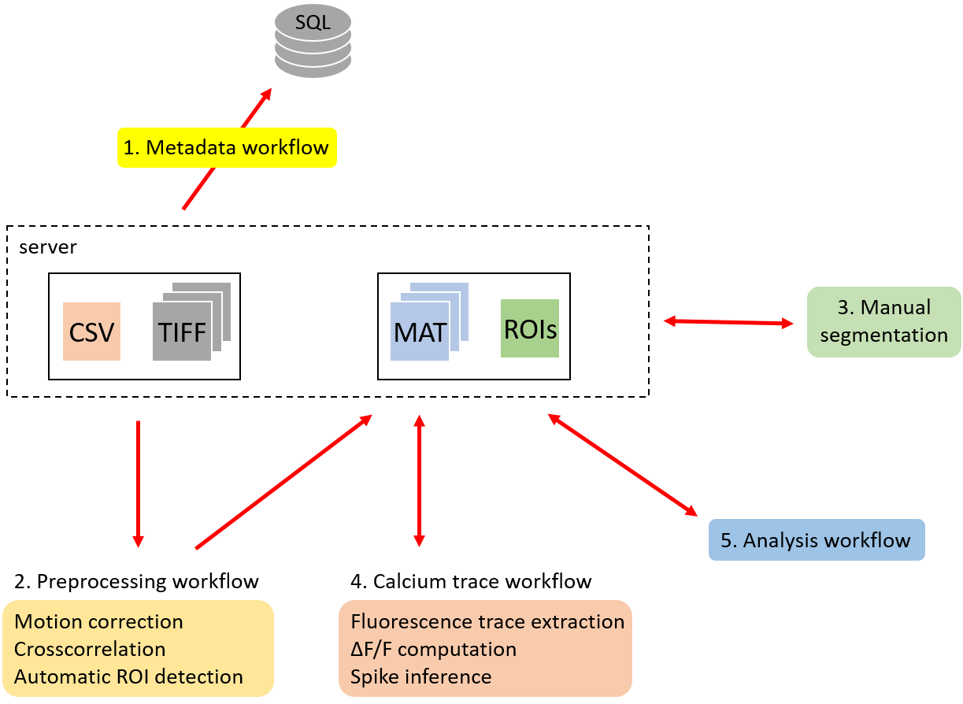

**Figure 1** - General description of work- and data-flows.

All workflows read from, and most also write to, the SQL database. Workflows are supposed to be run in sequence, from 1 to 5, although step 3 is optional. Bi-directional arrows indicate that data is also written back to the server, but in a different folder.

# File organization and naming convention

Imaging sessions are stored in files with extension .tif (TIFF files). TIFF files can be named freely, but their name should not contain spaces. TIFF files must be stored in the folder \2p_imaging_pain\1_raw_tiff\ on the shared drive GoupNevian4. Within this folder the experimenter has to create a subfolder indicating when the data was acquired according to the format YYMMDD, e.g., 170615 for 15 June 2017. Inside this folder, there should be another folder indicating the name of the imaged animal as reported in official documents, e.g., I2_1. This folder must contain all TIFF files for that animal and date, regardless of experimental protocol and whether the researcher counts to use them or not for the analysis. An example is reported in Fig. 2.

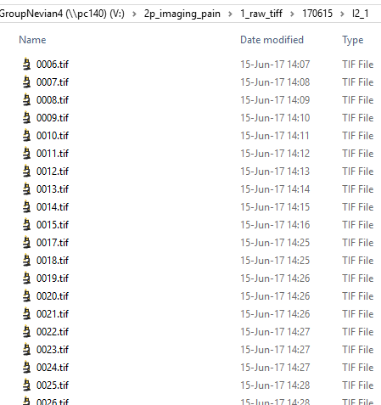

**Figure 2 -**